**Our Third Grade Book Reports**

Let’s have fun reading in third grade! This year you are expected to read and do six book reports. You may choose your own book and project. With each book you read, a different project needs to be completed. You must also choose a book from a different genre: **biography, historical fiction, science fiction, mystery, fables, myths, non-fiction, fiction, fairy tales and fantasy.**

Below is a list of requirements for your book reports.

1. Each of your reports will be shared with the class. Please choose from one of the projects listed. **Every project must be different!** Then pick a book from one of the genres. Remember, there are 10 different genres and you must read a book from 6 of them.
2. Each book must be approved by your parents before you begin reading it! Keep track of which project you choose and from what genre the book is from.
3. Here are the dates in which the reports are due the week of:

September 14, 2016

October 12, 2016

November 16, 2016

February 15, 2017

April 19, 2017

May 2017 (last week of school) **For this project a written book report form will be sent home for this one**!

1. You will need to give an oral report approx. 2-4 mins to the class. This is when you give a summary of your book and present your project. **An oral report must be given with each book project except if you are doing a video presentation!**  You may use notecards during oral report.



Third Grade Book Projects

1. **Clay Model**

C:\Users\Susan\AppData\Local\Microsoft\Windows\Temporary Internet Files\Content.IE5\DE30BWUM\MC900358435[1].wmfMake at least 2 clay figures or objects that are important in your book. You can make your figures using any type of clay. You may also paint the figures if you wish.

On another sheet of paper: write title of book, author. Include a paragraph describing your clay figures or objects. Please don’t forget to write your name at the bottom of paper.

1. **Comic Strip**

On a blank sheet of paper draw four squares. Within each square draw a picture of the four main events in your book. You may write words if you want the characters to be speaking. Include a title page with the title of your book, author, your name and date.

1. **Lights, Camera, Action!**

C:\Users\Susan\AppData\Local\Microsoft\Windows\Temporary Internet Files\Content.IE5\WCLFFNRI\MM900303339[1].gifThis is your chance to be an actor or actress! Choose an exciting part of your book to act out. If one of your classmates has read the same book and would like to perform with you then go ahead and do it together**! You may dress up and use props**. If you wish to use notecards to help you remember the lines that is fine! If you prefer, you can videotape it at home instead. You do not need to give an oral summary in class.

1. **Word Search**

Find 10-20 words or new vocabulary words from your book. Make a word search with the words in it. Include a list of your words. Then, make an answer sheet by highlighting your words. Turn in 3 sheets stapled: word list, word search, and an answer sheet. On one of the sheets make sure you have the title of book, author, and your name.

1. **Create a** **Quiz**

Create a quiz about your book. It can be multiple choice or true/false. Be sure to turn in both the quiz and answer key. On one of the sheets make sure you have the title of book, author, and your name.

1. **Author Letter**

Write a letter to the author of your story. Explain to him or her what you either liked or didn’t like about the book. Also, include any questions you may have or suggestions you have for a sequel.

1. **It’s All About Me**

Decorate a paper bag with the title of the book, author’s name and your name. Draw pictures of characters or objects that relate to your story. Then put 5-10 items that the main character of the story might put in his/her “me bag.”

In your oral report describe your main character and tell the class why your character would have these items in the “me bag.” Also include a summary of your book.

1. **T-Shirt Design**

Decorate a plain white T-shirt to reflect the book you read. You can illustrate a cover, the characters, your favorite part of the book, or anything else you can come up with that relates to your book! Please make sure the title and author is on it somewhere.

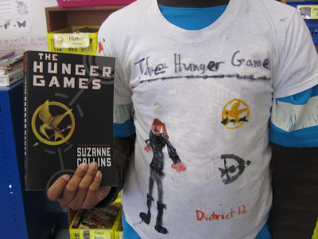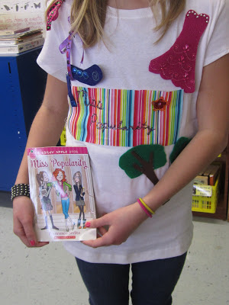

**9. PowerPoint**

Create a PowerPoint presentation summarizing the book you read. Be sure to include the main characters, the setting, the most important parts of your story, and why you either liked or didn’t like the book.

**10. Book Jacket**

Make a new book jacket for your book! On the front, create a new cover illustration and include the title and author. On the back, write a short summary of the book (without giving away the ending). On the inside flaps, write about your favorite part of the book.

**Don’t forget! You will also need to give an oral report which summarizes your book. (2-4 minutes long)**